### IBCS Admin dashboard

**Open URL:**

Open the following Link.

10.20.32.22:9006 (Like: https://ibcs.nift.pk)

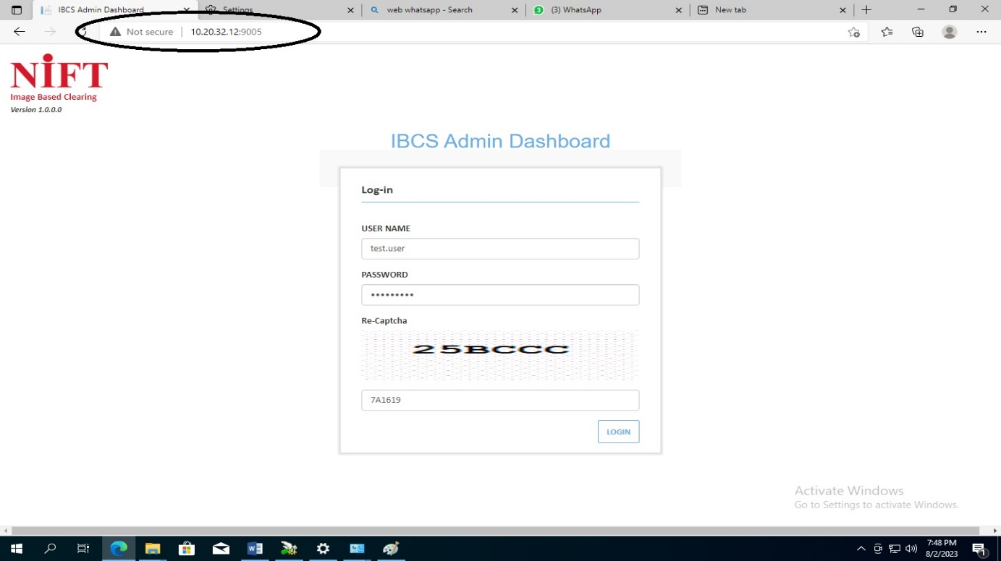

* Enter the COPS user name, password and captcha to login.

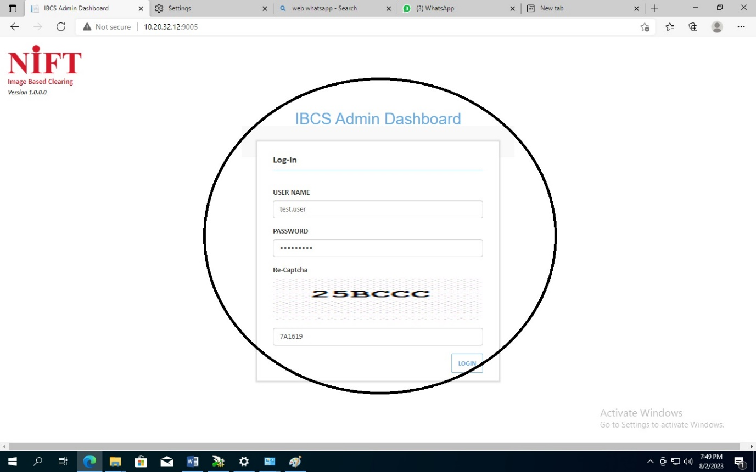

**Add Role:**

Now COPS user create bank role, so that the role can be added to bank’s user profile.

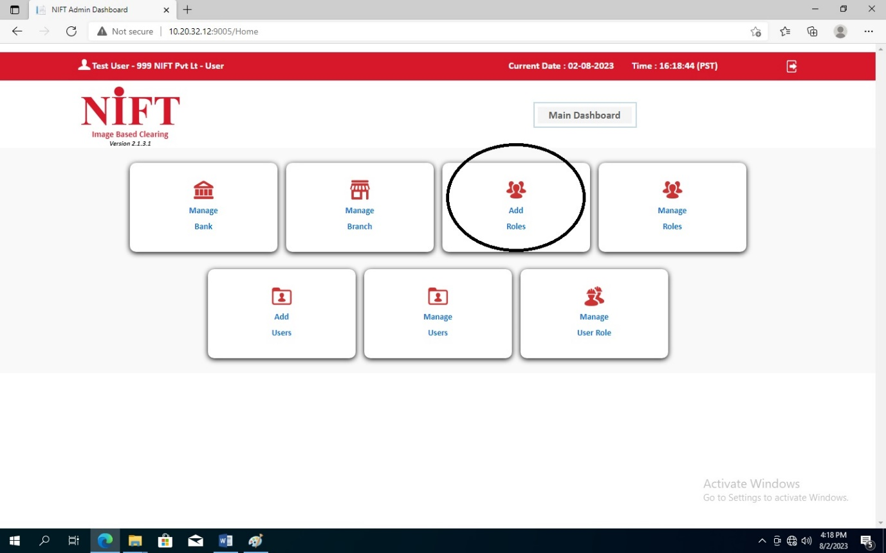

When creating a role here, you will give the role a name. Remember you cannot give the same name to two roles. So, this should be taken care of. Then the role will be created according to the user’s request. for example, which city, Bank, Branch, Treasury (Score Board) etc. you will mention in the role description which level the role belong to. After the role is created, the managed user will appear in the role. From here you can edit this role. As shown in the image below.

* Fill the Role Name and Role description…… select the User button and mark the View Images

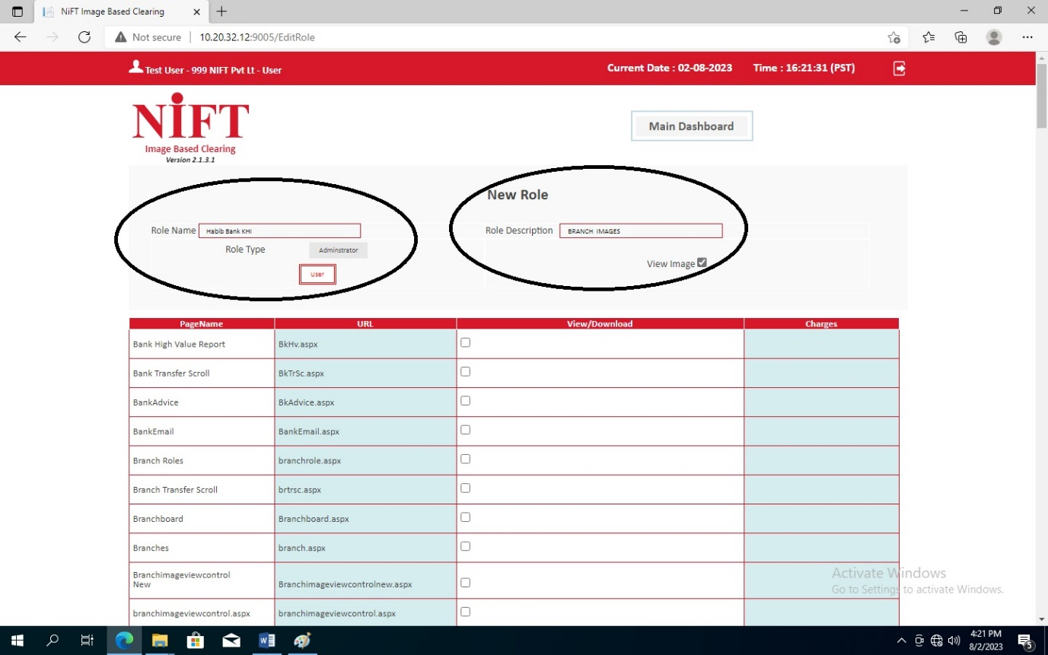

* Mark the bank user’s required options…... and click next button

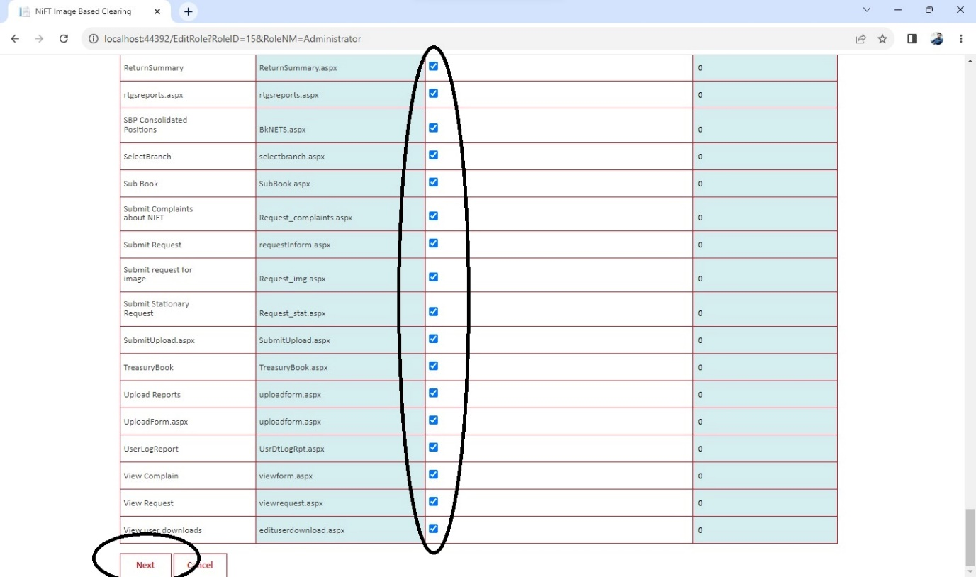

* Add city or city’s and Click next……. As per user requirement.

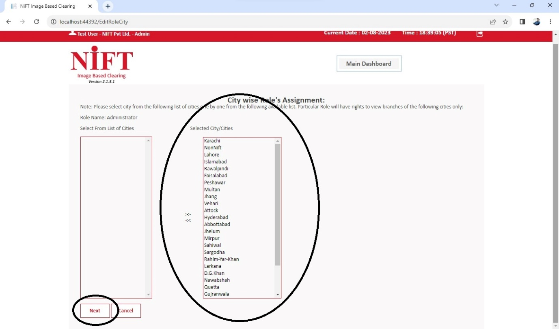

* Select Bank…….

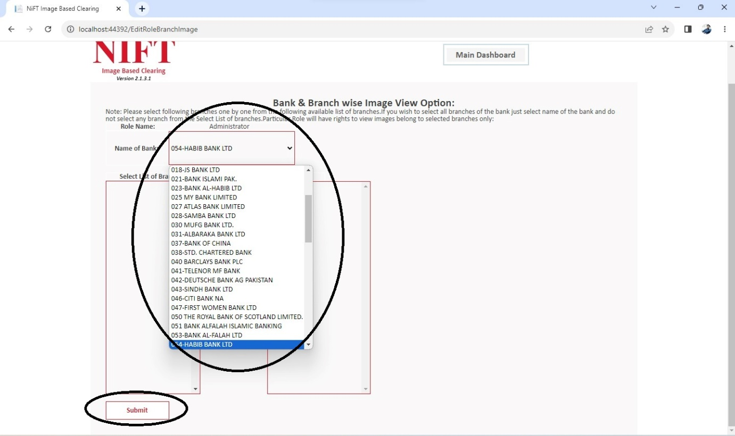

* Confirm Branch…….and click next button.

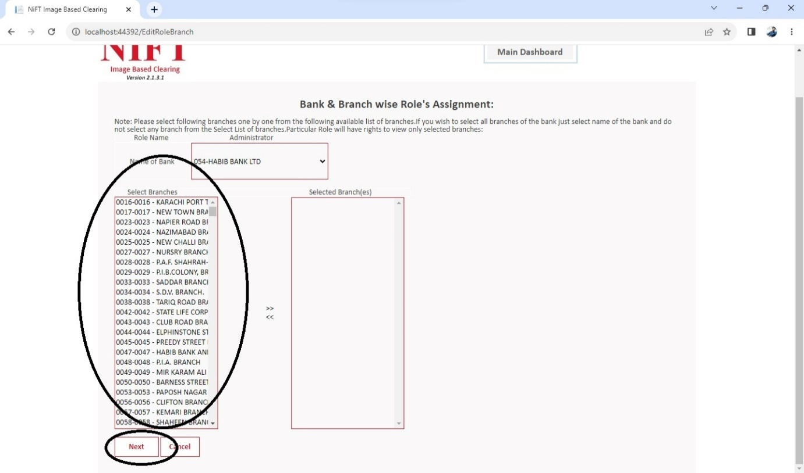

* Access Branch Images……. and click next button.



* Access Bank Data File, Hub File, ICL File……. Than Submit.

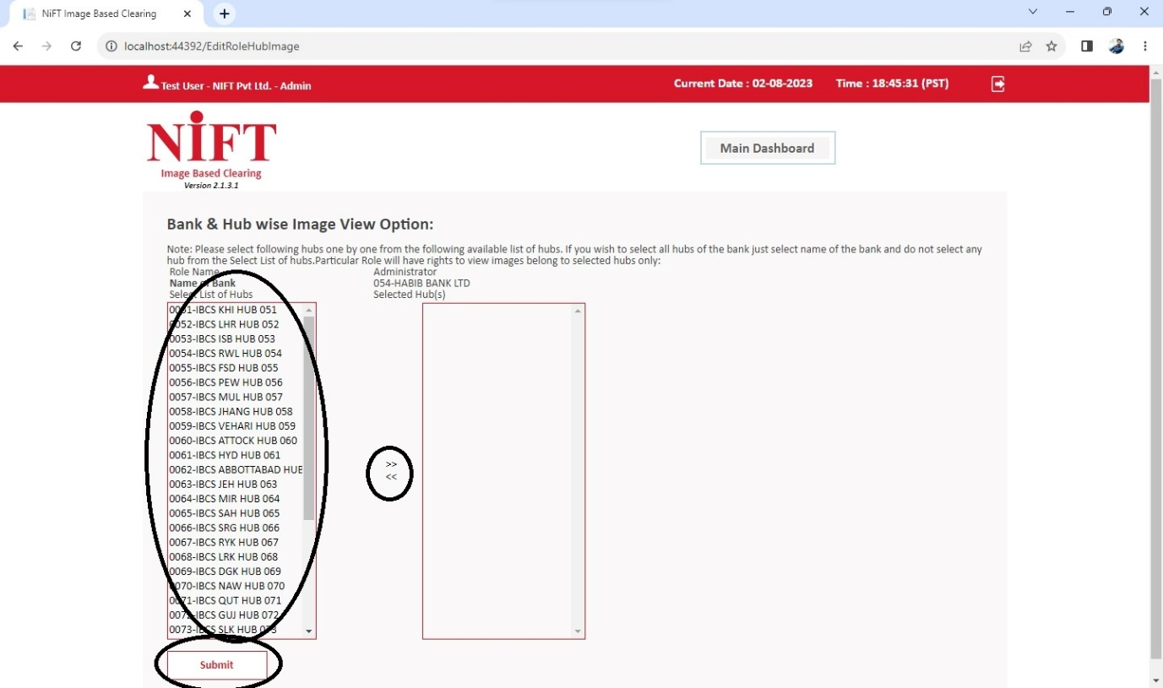

1. The created role will appear in the manage role like below…...

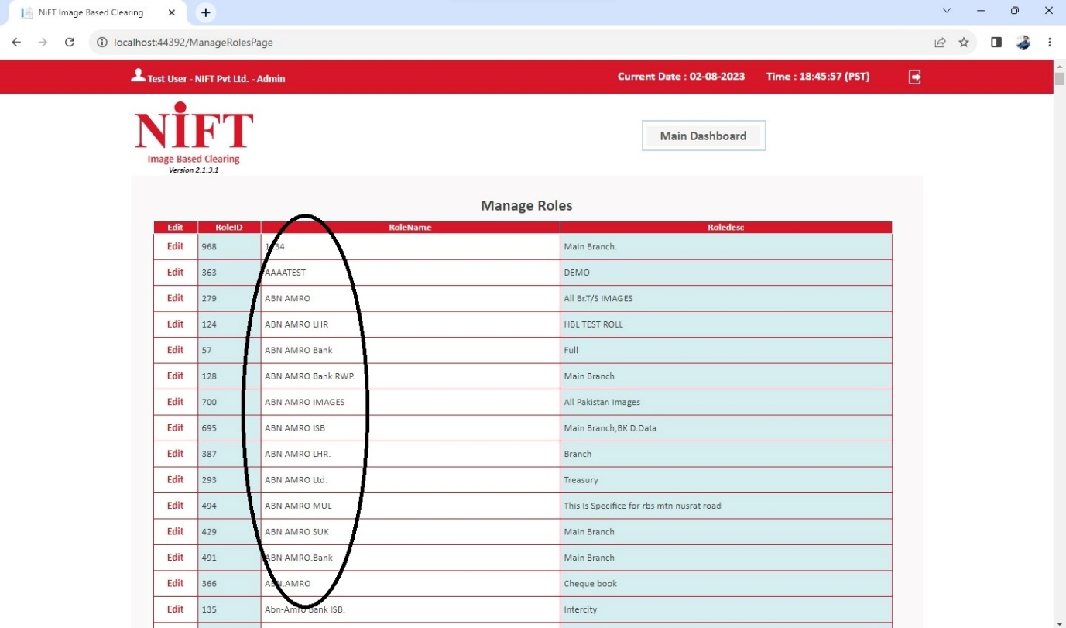

**Add User:**

You will then entre the user’s information in AddUser. For example, Name, Role, Bank code, Branch Code, Email ID, City, Issue Date, Expiry Date etc. After entering all user information, you will submit page.

* Click add user button

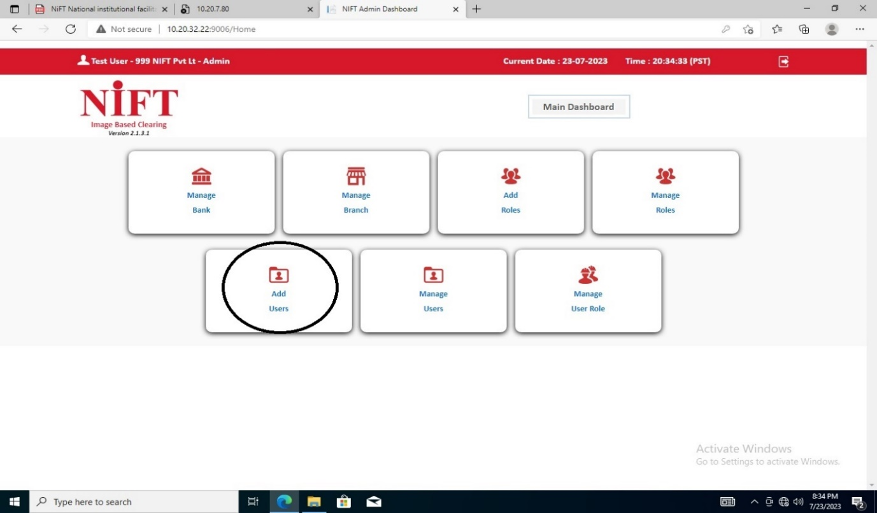

* Enter Bank User information as per request web service form received.

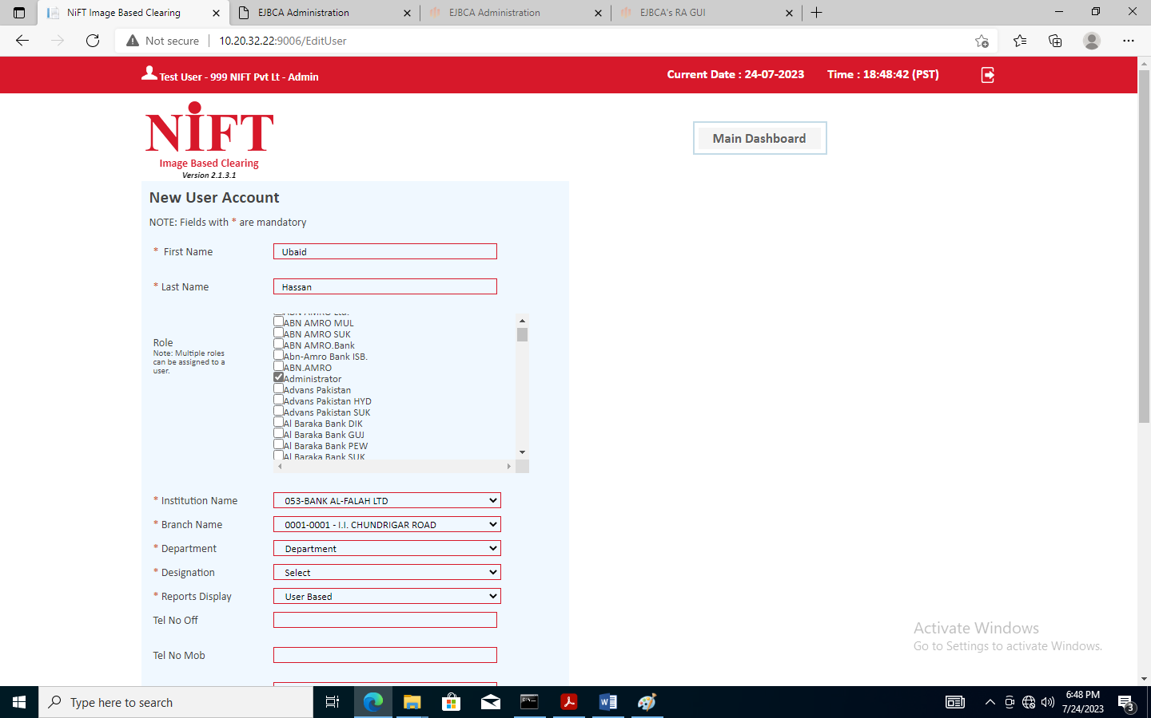

* User based means for a particular branch, however Role based means access right based on customized role

